DETECTING MALICIOUS FACEBOOK APPLICATIONS

ABSTRACT:

With 20 million installs a day [1], third-party apps area major reason for the popularity and addictiveness of Face book. Unfortunately, hackers have realized the potential of using apps for Spreading malware and spam. The problem is already significant, as we find that at least 13% of apps in our dataset are malicious. So far, the research community has focused on detecting malicious posts and campaigns. In this paper, we ask the question: Given a Face book application, can we determine if it is malicious? Our key contribution is in developing FRAppE—Face book’s Rigorous Application Evaluator—arguably the first tool focused on detecting malicious apps on Face book. To develop FRAppE, we use information gathered by observing the posting behavior of 111K Face book apps seen across 2.2 million users on Face book. First, we identify a set of features that help us distinguish malicious apps from benign ones. For example, we find that malicious apps often share names with other apps, and they typically request less permission than benign apps. Second, leveraging these distinguishing features, we show that FRAppE can detect malicious apps with 99.5% accuracy, with no false positives and a high true positive rate (95.9%).Finally; we explore the ecosystem of malicious Face book apps and identify mechanisms that these apps use to propagate. Interestingly, we find that many apps collude and support each other; in our dataset, we find 1584 apps enabling the viral propagation of 3723 other apps through their posts. Long term, we see FRAppE as a step toward creating an independent watchdog for app assessment and ranking, so as to warn Face book users before installing apps.

EXISTING SYSTEM:
ONLINE social networks (OSNs) enable and encourage third-party applications (apps) to enhance the user experience on these platforms. Such enhancements include interesting or entertaining ways of communicating among online friends and diverse activities such as playing games or listening to songs. For example, Face book provides developers an API that facilitates app integration into the Face book user- experience. There are 500Kapps available on Face book, and on average, 20M apps are installed every day. Furthermore, many apps have acquired and maintain a really large user base. For instance, Farm Ville and City Ville apps have 26.5Mand 42.8M users to date. Recently, hackers have started taking advantage of the popularity of this third-party apps platform and deploying malicious applications. Malicious apps can provide a lucrative business for hackers, given the popularity of OSNs, with Face book leading the way with 900M active users. There are many ways that hackers can benefit from a malicious app:
- The app can reach large numbers of users and their friends to spread spam;
- The app can obtain users’ personal information such as e-mail address, home town, and gender; and
- The app can “reproduce” by making other malicious apps popular .To make matters worse; the deployment of malicious apps is simplified by ready-to-use toolkits starting at $25 [8]. In other words, there is motive and opportunity, and as a result, there are many malicious apps spreading on Face book every day [9].

DISADVANTAGES:
- Privacy and security is not available.
- Hackers are more benefit from malicious apps.

PROPOSED SYSTEM:
We develop FRAppE, a suite of efficient classification techniques for identifying whether an app is malicious or not. To build FRAppE, we use data from My Page-Keeper, a security app in Face book that monitors the Face book profiles of 2.2 million users. We analyze 111K apps that made 91 million posts over 9 months. This is arguably the first comprehensive study focusing on malicious Face book apps that focuses on quantifying, profiling, and understanding malicious apps and synthesizes this information into an effective detection approach. Our work makes the following key contributions.
    - 13% of observed apps are malicious
    - Malicious and benign app profiles significantly differ.
    - The emergence of app-nets: Apps collude at massive scale.
    - Malicious hackers impersonate applications
    - FRAppE can detect malicious apps with 99% accuracy.
ADVANTAGES:
- Privacy and security.
- Reducing the menace of hackers.
- Malicious apps with 99% accuracy.

SYSTEM CONFIGURATION:-

HARDWARE CONFIGURATION:

Processor : Pentium –IV
- Speed : 1.1 GHz
- RAM : 256 MB(min)
- Hard Disk : 20 GB
- Key Board : Standard Windows Keyboard
- Mouse : Two or Three Button Mouse
- Monitor : SVGA

SOFTWARE CONFIGURATION:
- Operating System : Windows95/98/2000/XP/7.
- Application Server : Tomcat6.0/7.X.
- Front End : HTML, Java, Jsp.
- Scripts : JavaScript.
- Server side Script : Java Server Pages.
- Database : Mysql 5.0.
- Database Connectivity : JDBC.

SYSTEM MODEL:

SYSTEM ARCHITECTURE:
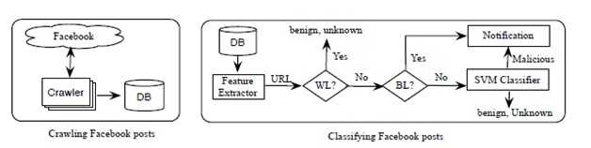

MODULES:

- Malicious and benign app profiles significantly differ
- The emergence of AppNets: apps collude at massive scale
- Malicious hackers impersonate applications.
- FRAppE can detect malicious apps with 99% accuracy

Malicious and benign app profiles significantly differ:

We systematically profile apps and show that malicious app profiles are significantly different than those of benign apps. A striking observation is the “laziness” of hackers; many malicious apps have the same name, as 8% of unique names of malicious apps are each used by more than 10 different apps (as defined by their app IDs). Overall, we profile apps based on two classes of features: (a) those that can be obtained on-demand given an application’s identifier (e.g., the permissions required by the app and the posts in the application’s profile page), and (b) others that require a cross-user view to aggregate information across time and across apps (e.g., the posting behavior of the app and the similarity of its name to other apps).

The emergence of AppNets: apps collude at massive scale:

We conduct a forensics investigation on the malicious app ecosystem to identify and quantify the techniques used to promote malicious apps. The most interesting result is that apps collude and collaborate at a massive scale. Apps promote other apps via posts that point to the “promoted” apps. If we describe the collusion relationship of promoting-promoted apps as a graph, we find
1,584 promoter apps that promote 3,723 other apps. Furthermore, these apps form large and highly-dense connected components, furthermore, hackers use fast-changing indirection: applications posts have URLs that point to a website, and the website dynamically redirects to many different apps; we find 103 such URLs that point to 4,676 different malicious apps over the course of a month. These observed behaviors indicate well-organized crime: one hacker controls many malicious apps, which we will call an AppNet, since they seem a parallel concept to botnets.

Malicious hackers impersonate applications:
We were surprised to find popular good apps, such as ‘FarmVille’ and ‘Facebook for iPhone’, posting malicious posts. On further investigation, we found a lax authentication rule in Facebook that enabled hackers to make malicious posts appear as though they came from these apps.

FRAppE can detect malicious apps with 99% accuracy:

We develop FRAppE (Facebook’s Rigorous Application Evaluator) to identify malicious apps either using only features that can be obtained on-demand or using both on-demand and aggregation based app information. FRAppE Lite, which only uses information available on-demand, can identify malicious apps with 99.0% accuracy, with low false positives (0.1%) and false negatives(4.4%). By adding aggregation-based information, FRAppE can detect malicious apps with 99.5% accuracy, with no false positives and lower false negatives (4.1%).

ER Diagram
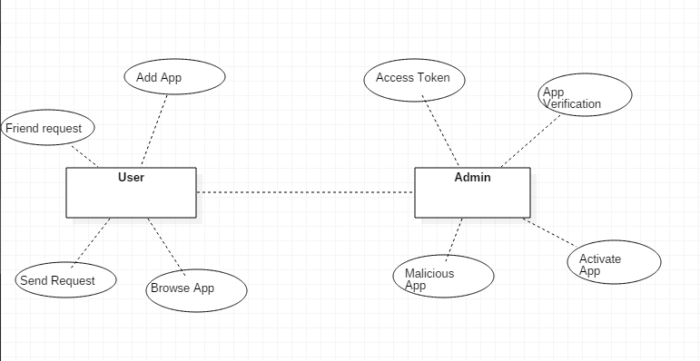

Use Case Diagram

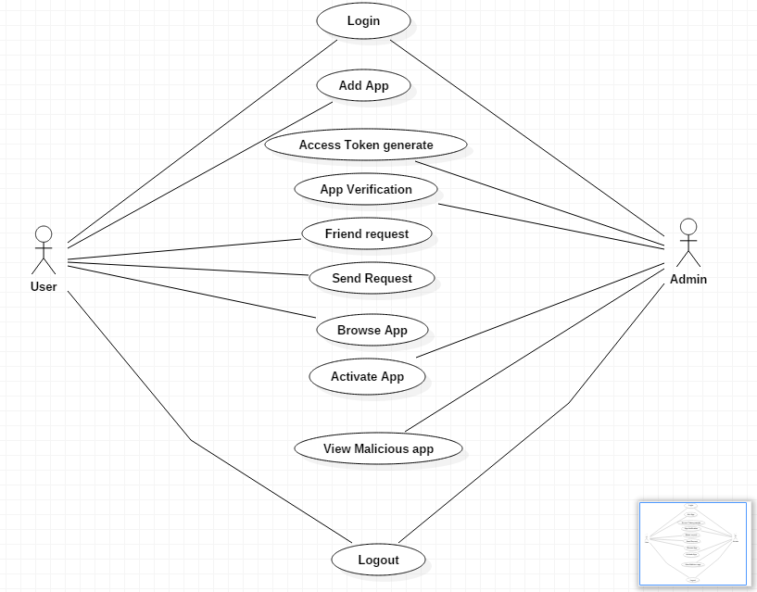

Sequence Diagram

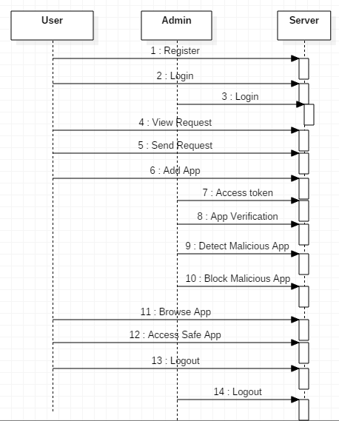

INTRODUCTION
Online social networks (OSNs) enable and encourage third-party applications (apps) to enhance the user experience on these platforms. Such enhancements include interesting or entertaining ways of communicating among online friends and diverse activities such as playing games or listening to songs. For example, Facebook provides developers an API that facilitates app integration into the Facebook user- experience. There are 500K apps available on Facebook, and on average, 20M apps are installed every day. Furthermore, many apps have acquired and maintain a really large user base. For instance, FarmVille and CityVille apps have 26.5M and 42.8M users to date. Recently, hackers have started taking advantage of the popularity of this third-party apps platform and deploying malicious applications. Malicious apps can provide a lucrative business for hackers, given the popularity of OSNs, with Facebook leading the way with 900M active users. There are many ways that hackers can benefit from a malicious app:
1) the app can reach large numbers of users and their friends to spread spam; 2) the app can obtain users’ personal information such as e-mail address, home town, and gender; and 3) the app can “reproduce” by making other malicious apps popular. To make matters worse, the deployment of malicious apps is simplified by ready-to-use toolkits starting at $25 [8]. In other words, there is motive and opportunity, and as a result, there are many malicious apps spreading on Facebook every day.
Despite the above worrisome trends, today a user has very limited information at the time of installing an app on Facebook. In other words, the problem is the following: Given an app’s identity number (the unique identifier assigned to the app by Facebook), can we detect if the app is malicious? Currently, there is no commercial service, publicly available information, or research-based tool to advise a user about the risks of an app. As we show in Section III, malicious apps are widespread and they easily spread, as an infected user jeopardizes the safety of all its friends. So far, the research community has paid little attention to OSN apps specifically. Most research related to spam and malware on Facebook has focused on detecting malicious posts and social spam campaigns. At the same time, in a seemingly backwards step, Facebook has dismantled its app rating functionality recently. A recent work studies how app permissions and community ratings correlate to privacy risks of Facebook apps . Finally, there are some community- based feedback-driven efforts to rank applications, such as WhatApp? ; though these could be very powerful in the future, so far they have received little adoption. We discuss previous work in more detail in Section VIII. In this paper, we develop FRAppE, a suite
of efficient classification techniques for identifying whether an app is malicious or not. To build FRAppE, we use data from MyPage- Keeper, a security app in Facebook [15] that monitors the Facebook profiles of 2.2 million users. We analyze 111K apps that made 91 million posts over 9 months. This is arguably the first comprehensive study focusing on malicious Facebook apps that focuses on quantifying, profiling, and understanding malicious apps and synthesizes this information into an effective detection approach.

Literature Survey
Topic: Towards Online Spam Filtering in Social Networks
Author: Hongyu Gao, Yan Chen, Kathy Lee
Online social networks (OSNs) are extremely popular among Internet users. Unfortunately, in the wrong hands, they are also effective tools for executing spam campaigns. In this paper, we present an online spam filtering system that can be deployed as a component of the OSN platform to inspect messages generated by users in real-time. We propose to reconstruct spam messages into campaigns for classification rather than examine them individually. Although campaign identification has been used for offline spam analysis, we apply this technique to aid the online spam detection problem with sufficiently low overhead. Accordingly, our system adopts a set of novel features that effectively distinguish spam campaigns. It drops messages classified as “spam” before they reach the intended recipients, thus protecting them from various kinds of fraud. We evaluate the system using 187 million wall posts collected from Facebook and 17 million tweets collected from Twitter. In different parameter settings, the true positive rate reaches 80.9% while the false positive rate reaches 0.19% in the best case. In addition, it stays accurate for more than 9 months after the initial training phase. Once deployed, it can constantly secure the OSNs without the need for frequent re-training.

Topic: Poking Facebook: Characterization of OSN Applications
Author: Minas Gjoka, Michael Sirivianos, Athina Markopoulou, Xiaowei Yang
Facebook is one of the most popular Internet sites today. A key feature that arguably contributed to Facebook’s unprecedented success is its application platform, which enables the development of thirdparty social-networking applications. Understanding how these applications
are installed and used is important for the function and utility of web-based online social networks, e.g. to better engineer them and/or to design advertising campaigns. In this paper, we characterize the popularity and user reach of Facebook applications. We analyze application usage data gathered over a period of six months from Facebook and Adonomics - a Facebook analytics service. We also crawl publicly accessible Facebook user profiles and obtain per-user application installation statistics, for approximately 300K users and 13.6K applications. Our findings include that (i) the popularity of Facebook applications has a highly skewed distribution; (ii) although the total number of application installations increases with time, the average user activity decreases; and (iii) users with more applications installed are more likely to install new applications.

Topic: Detecting and Characterizing Social Spam Campaigns
Author: Hongyu Gao, Jun Hu, Christo Wilson
Online social networks (OSNs) are popular collaboration and communication tools for millions of users and their friends. Unfortunately, in the wrong hands, they are also effective tools for executing spam campaigns and spreading malware. Intuitively, a user is more likely to respond to a message from a Facebook friend than from a stranger, thus making social spam a more effective distribution mechanism than traditional email. In fact, existing evidence shows malicious entities are already attempting to compromise OSN account credentials to support these “high-return” spam campaigns.
In this paper, we present an initial study to quantify and characterize spam campaigns launched using accounts on online social networks. We study a large anonymized dataset of asynchronous “wall” messages between Facebook users. We analyze all wall messages received by roughly 3.5 million Facebook users (more than 187 million messages in all), and use a set of automated techniques to detect and characterize coordinated spam campaigns. Our system detected roughly 200,000 malicious wall posts with embedded URLs, originating from more than 57,000 user accounts. We find that more than 70% of all malicious wall posts advertise phishing
sites. We also study the characteristics of malicious accounts, and see that more than 97% are compromised accounts, rather than “fake” accounts created solely for the purpose of spamming. Finally, we observe that, when adjusted to the local time of the sender, spamming dominates actual wall post activity in the early morning hours, when normal users are asleep.

Topic: Design and Evaluation of a Real-Time URL Spam Filtering Service
Author: Kurt Thomas*, Chris Grier*y, Justin Ma*, Vern Paxson*y, Dawn Song*
On the heels of the widespread adoption of web services such as social networks and URL shorteners, scams, phishing, and malware have become regular threats. Despite extensive research, email-based spam filtering techniques generally fall short for protecting other web services. To better address this need, we present Monarch, a real-time system that crawls URLs as they are submitted to web services and determines whether the URLs direct to spam. We evaluate the viability of Monarch and the fundamental challenges that arise due to the diversity of web service spam. We show that Monarch can provide accurate, real-time protection, but that the underlying characteristics of spam do not generalize across web services. In particular, we find that spam targeting email qualitatively differs in significant ways from spam campaigns targeting Twitter. We explore the distinctions between email and Twitter spam, including the abuse of public web hosting and redirector services. Finally, we demonstrate Monarch’s scalability, showing our system could protect a service such as Twitter— which needs to process 15 million URLs/day—for a bit under $800/day.

