NETWORK INTRUSION DETECTION AND COUNTERMEASURE
SELECTION IN VIRTUAL NETWORK SYSTEMS-NICE
ABSTRACT:
Cloud security is one of most important issues that has attracted a lot of research and development effort in past few years. Particularly, attackers can explore vulnerabilities of a cloud system and compromise virtual machines to deploy further large-scale Distributed Denial-of-Service (DDoS). DDoS attacks usually involve early stage actions such as multi-step exploitation, low frequency vulnerability scanning, and compromising identified vulnerable virtual machines as zombies, and finally DDoS attacks through the compromised zombies.
Within the cloud system, especially the Infrastructure-as-a-Service (IaaS) clouds, the detection of zombie exploration attacks is extremely difficult. This is because cloud users may install vulnerable applications on their virtual machines. To prevent vulnerable virtual machines from being compromised in the cloud, we propose a multi-phase distributed vulnerability detection, measurement, and countermeasure selection mechanism called NICE, which is built on attack graph based analytical models and reconfigurable virtual network-based countermeasures. The proposed framework leverages OpenFlow network programming APIs to build a monitor and control plane over distributed programmable virtual switches in order to significantly improve attack detection and mitigate attack consequences. The system and security evaluations demonstrate the efficiency and effectiveness of the proposed solution.

EXISTING SYSTEM:
Cloud users can install vulnerable software on their VMs, which essentially contributes to loopholes in cloud security. The challenge is to establish an effective vulnerability/attack detection and response system for accurately identifying attacks and minimizing the impact of security breach to cloud users. Addressed that protecting ”Business continuity and services availability” from service outages is one of the top concerns in cloud computing systems.
In a cloud system where the infrastructure is shared by potentially millions of users, abuse and nefarious use of the shared infrastructure benefits attackers to exploit vulnerabilities of the cloud and use its resource to deploy attacks in more efficient ways. Such attacks are more effective in the cloud environment since cloud users usually share computing resources, e.g., being connected through the same switch, sharing with the same data storage and file systems, even with potential attackers. The similar setup for vms in the cloud, e.g., virtualization techniques, VM OS, installed vulnerable software, networking, etc., attracts attackers to compromise multiple vms.
DISADVANTAGES OF EXISTING SYSTEM:
- No detection and prevention framework in a virtual networking environment.
- Not accuracy in the attack detection from attackers.

PROPOSED SYSTEM:
We propose NICE (Network Intrusion detection and Countermeasure selection in virtual network systems) to establish a defense-in-depth intrusion detection framework. For better attack detection, NICE incorporates attack graph analytical procedures into the intrusion detection processes. We must note that the design of NICE does not intend to improve any of the existing intrusion detection algorithms; indeed, NICE employs a reconfigurable virtual networking approach to detect and counter the attempts to compromise vms, thus preventing zombie vms.
ADVANTAGES OF PROPOSED SYSTEM:
- We devise NICE, a new multi-phase distributed network intrusion detection and prevention framework in a virtual networking environment that captures and inspects suspicious cloud traffic without interrupting users’ applications and cloud services.
- NICE incorporates a software switching solution to quarantine and inspect suspicious VMs for further investigation and protection. Through programmable network approaches, NICE can improve the attack detection probability and improve the resiliency to VM exploitation attack without interrupting existing normal cloud services.
- NICE employs a novel attack graph approach for attack detection and prevention by correlating attack behavior and also suggests effective countermeasures.
- NICE optimizes the implementation on cloud servers to minimize resource consumption. Our study shows that NICE consumes less computational overhead compared to proxy-based network intrusion detection solutions.

ARCHITECTURE:

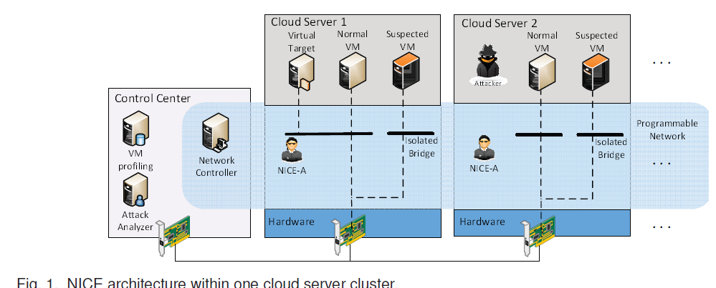

SYSTEM CONFIGURATION:

HARDWARE CONFIGURATION:

Processor - Pentium –IV
- Speed - 1.1 Ghz
- RAM - 256 MB(min)
- Hard Disk - 20 GB
- Key Board - Standard Windows Keyboard
- Mouse - Two or Three Button Mouse
- Monitor - SVGA

SOFTWARE CONFIGURATION:
- Operating system - Windows XP.
- Coding Language - ASP.Net,C#.Net.
- Data Base - SQL Server 2005
- Tool - VISUAL STUDIO 2008.

